Text 9

Sony DAVS888
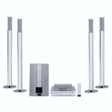  Save £70 | Ultra cool DVD Home Cinema System  Four beautiful, slim floor-standing speakers and an active subwoofer to bring you a great entertainment experience. A powerful player/S-Master digital amplifier, boosting 5 x 100W, facilitates DVD-Video, multi-channel Super Audio CD, Video CD and DVD-R/RW playback, while an integrated RDS tuner provides 30 pre-set channel options. This is a true one box solution for your TV!  Comet Price £593.83  Our Price £519.98

