全文

<http://www.xinhuanet.com/politics/leaders/2020-09/22/c_1126527652.htm>

视频 （da 1:35）[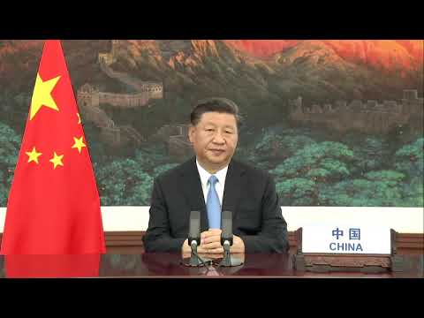](https://www.youtube.com/watch?v=W2hQ93mL4ZU)