LEAP Base Course - Lesson 10 - General Review

Task 1 - Adverbs of Frequency
100% |  |  | 50% |  |  | 0%
always | usually | often | sometimes | occasionally | rarely | never

How often do you…
go to the gym?
speak English outside of class?
eat out at a restaurant?
cook at home?
check social media?

How often are you…
late for work?
on time for work?
home before 4pm?
tired in the morning?

Put the words in the correct order:

- goes / She / the gym / always / to
- tired / never / is / He
- sometimes / breakfast / skip / I
- usually / weekends / on / We / relax
- nervous / are / before / often / exams / They
- occasionally / works / from home / He
- rarely / I / vegetables / eat

Listening. Listen to the speakers and choose the correct answer:
https://test-english.com/listening/a1/how-often-do-you-a1-english-listening-test/

1. Brian goes shopping for food ________.
a. once a week
b. twice a week
c. every weekend.

2. Brian ________ goes shopping for clothes.
a. often
b. never
c. rarely

3. Oliver plays football ____________.
a. every weekend
b. once a week
c. twice a week

4. Emily has coffee __________.
a. twice a day
b. twice a month
c. every weekend

5. Emily ________ has tea.
a. often
b. hardly ever
c. never

6. George ___________ calls his mum.
a. rarely
b. always
c. sometimes

7. George’s mother calls George _________.
a. every day
b. once a week
c. three or four times a week

8. Lucy eats out _________.
a. twice a week
b. three times a week
c. once a week

Task 2 Present Perfect v Past Simple
Present perfect ( has/have + past participle) - for unfinished time
Past Simple (verb+ed) - for finished time

1) Are the underlined parts of these sentences right or wrong? Correct them where necessary.
- I’ve lost my key. I can’t find it anywhere.
- Have you eaten a lot of sweets when you were a child?
- I’ve bought a new car. You must come and see it.
- I’ve bought a new car last week.
- Where have you been yesterday evening?
- Lucy has left school in 1999.
- I’m looking for Mike. Have you seen him?
- “Have you been to Paris?” “Yes, many times.”
- I’m very hungry. I haven’t eaten much today.
- When has this book been published?

2) Make sentences from the words in brackets. Use the present perfect or the past simple.
- (it / not / rain / this week)
- (the weather / be / cold / recently)
- (it / cold / last week)
- (I / not / read / a newspaper yesterday)
- (I / not / read / a newspaper today)
- (Emily / earn / a lot of money / this year)
- (She / not / earn / so much / last year)
- (You / have / a holiday recently?)

Read the following paragraph and correct any errors you see:
I have visited Portugal for the first time three years ago. I went there with my sister, and we stayed in Lisbon for a week. We have seen so many beautiful places while we were there. Since that trip, I have travelled to four more countries in Europe. Last year, I went back to Portugal again, but this time I went to Porto instead. I never tried Portuguese custard tarts before that second trip. My sister has lived in Lisbon for six months now, because she loves the city so much. She moved there last September after she finished her degree. I have already planned my next visit for this summer. I didn't decide yet whether I will stay with my sister or book a hotel.

Task 4 Relative pronouns

Choose the correct word (who /which/ that/ where) to fill the gap:

- The man ___ called you yesterday is my uncle.
- This is the book ___ I borrowed from the library.
- That's the restaurant ___ we had our first date.
- I have a colleague ___ speaks four languages.
- The phone ___ I bought last month is already broken.
- Do you know the woman ___ is sitting next to the window?
- This is the city ___ I was born.
- The film ___ won the prize was really boring.
- He's the teacher ___ helped me with my English.
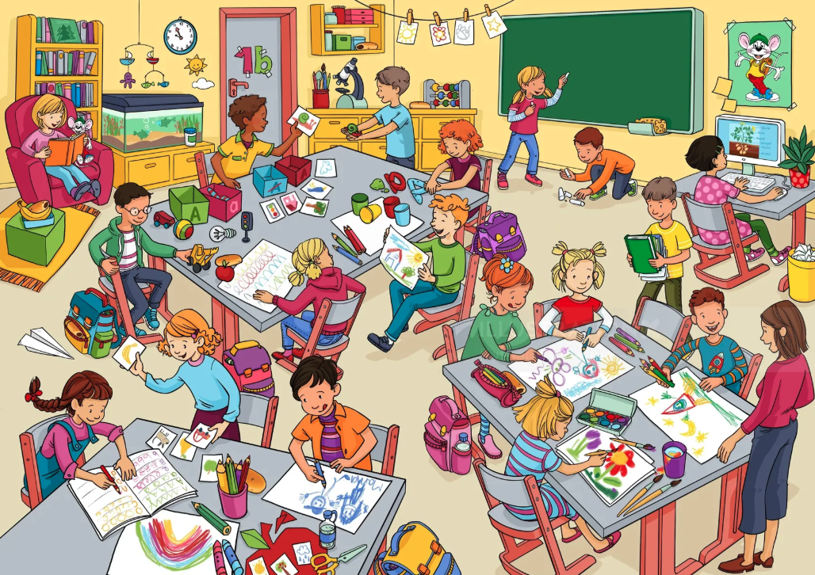
- I still have the watch ___ my grandfather gave me.

Write 5 sentences about this picture, using relative pronouns.
Example:
The girl who is sitting in the pink armchair is reading a book.

1.
2.
3.
4.
5.

Task 5 - Video
Watch the short film and then answer the questions together.
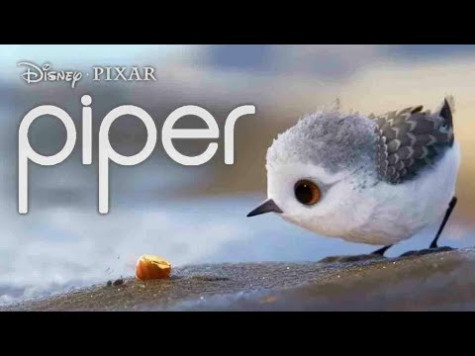

- Where does the story happen?
- Who are the two main characters?
- What is the baby bird afraid of at the beginning?
- What does the small crab teach her?
- What happens to the bird at the end of the film?
- What did the bird do the first time she tried to find food in the water?
- How has the bird changed from the beginning of the film to the end?
- What can you say about the crab? (Use a relative pronoun in your answer)
- How often are you afraid to try something new, like the bird at the start of the film?
- Are there things you used to do rarely but now do often, like the bird with the water?

