LEAP Base Course - Lesson 8

Task 1: Watch the following short film (The Perfect Egg) then answer the questions below
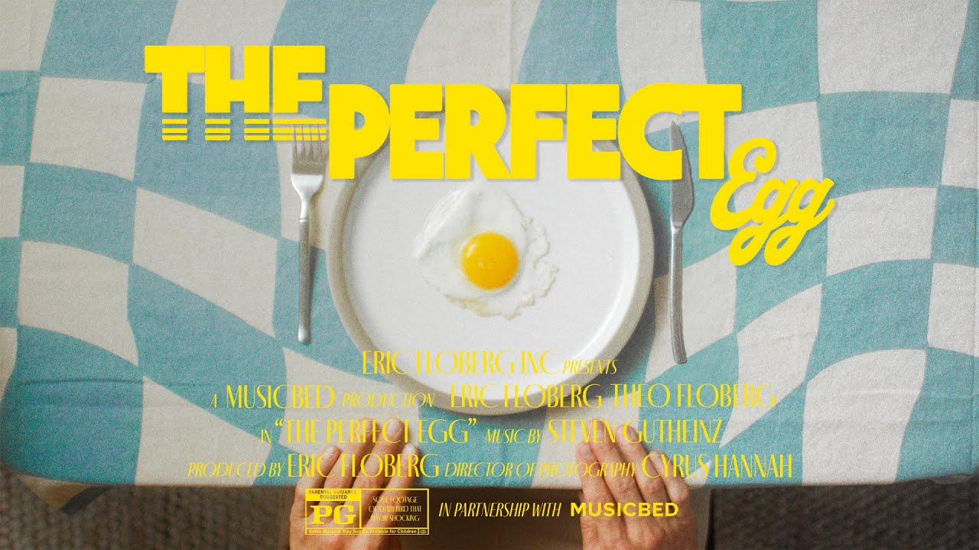

- Who are the main characters in the film?
- What does the father want to make for his son?
- Why does the father keep making new eggs?
- How does the father feel when the egg is not perfect?
- What happens at the end of the film?
- Which scene did you like the most? Why?
- What do you think is the message of the film?

Task 2 - In your own words

Watch the film again. Tell the class the story in 5-6 sentences, using these words:

First, next, after that, later, finally.

Example: First, the father cooked an egg. Then he served it to his son. After that…..

(*Remember to use the past simple!)

Task 3 - Discussion - in pairs/groups of 3, ask and answer the following questions. (Make sure to take notes on what your partner says!)

- Have you ever cooked a meal for someone else?
- Have you ever tried to make something perfect?
- Have you ever burned or ruined some food?
- Have you ever worked hard to make someone happy?
- Have you ever felt disappointed because something didn't go as planned?
- Have you ever received a gift or favour that made you happy?
- Have you ever learned how to cook a new dish?
- Have you ever done something special for a family member?
- Have you ever made the same mistake more than once?
- Have you ever given up on something because it was too difficult?

(*Remember to use the present perfect to begin, then the past simple if you go into more detail)

Task 4 - Debate.

Is It Better to Be Perfect or Happy?

Team A - It is important to do things perfectly.

Some ideas to help you:
- Good work is important.
- People respect quality.
- Mistakes can cause problems.

Team B - It is more important to be happy than perfect.

Some ideas to help you:
- Nobody is perfect.
- Mistakes help us learn.
- Perfection can cause stress.

