L12 - LINGUA E TRADUZIONE INGLESE III
Modulo B Lingua e Traduzione per L’impresa Internazionale a.a. 2022-2023
LETTORATO Dott.ssa M. Condon/ Dott.ssa R.O’Doherty
marie.condon@unimc.it
rebecca.odoherty@unimc .it

15/3/2023

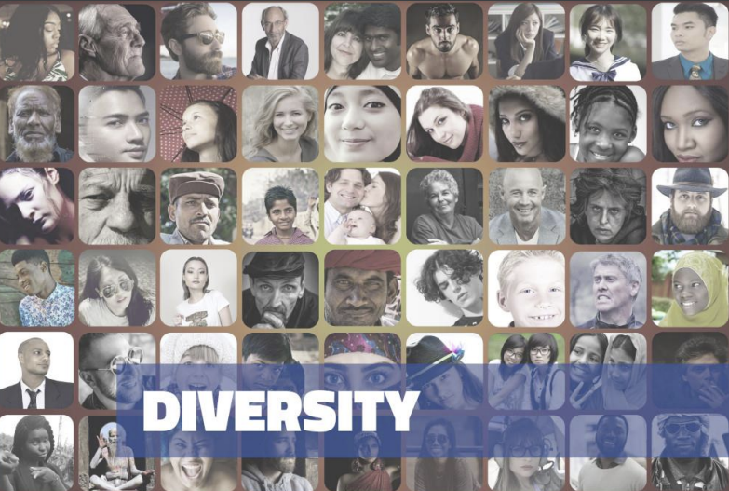

“When everyone is included, everyone wins.”
Jesse Jackson, American Baptist minister and politician

Read the quote above.
What do you think it means?
Do you agree or disagree with it?
How do you think it could relate to business?

DISCUSS:
1. What does a diverse workplace look like?
2. What are the advantages of having a diverse workforce?
3. What can businesses do to increase diversity?
4. What kind of discrimination exists in the workplace?
5. Are companies just paying lip service to diversity to boost their reputation?
6. Should all companies provide diversity training to their staff? Why or why not? What should this training consist of?

VOCABULARY:
Match the words/phrases with their definitions:
1) inclusion (noun), inclusive (adjective) | a) to exclude or ignore a group of people.
2) to marginalise (verb), marginalisation (noun), marginalised (adjective) | b) hostile communication, either verbal or nonverbal, intentional or unintentional, towards a different group.
3) ethnic minority (noun | c) any ethic group with the exception of the majority group.
4) unconscious / hidden / implicit bias (noun) | d) the practice of favouring groups that have been traditionally discriminated against in recruitment or promotion processes
5) microaggression (noun) | e) prejudices or stereotypes unconsciously attributed to a group of people.
6) affirmative action (AmE), positive discrimination (noun) | f) to bring all people together, especially those traditionally excluded.

Using the vocabulary words above, complete the following sentences (remember to use the correct form of the word, e.g. verb conjugation or plural noun)
1. Almost 20% of FTSE 100 companies have no ___________representation at the board level.
2. I’m tired of Tony’s __________. Yesterday he told me that my idea was very good for a woman.
3. In order to boost diversity in the workplace, Wayland-Yutani Corporation decided to implement a policy of ____________ whereby candidates from ethnic minorities would be given priority during the hiring process, as long as they met the minimum criteria.
4. JLB tried to create an ____________ environment by surveying all staff to see if they had experienced any kind of discrimination in the workplace.
5. __________ during interviews is one of the main reasons women and ethnic minorities are underrepresented in management positions.
6. Unfortunately, women often play a secondary role at management level or are ___________ completely.

Video: You are going to watch a TEDx Talk by Arwa Mahdawi called “The Surprising Solution to Workplace Diversity.”
Watch the video here: https://www.youtube.com/watch?v=mtUlRYXJ0vI

After watching the video, discuss the following questions:
1. Why don’t people want to talk about diversity?
2. Do you think that some people get hired just to tick a diversity box? Do you think companies would ‘rent’ diversity if they could?
3. Is diversity really a priority for businesses, or is it just a secondary problem for them that needs to be solved?
4. Considering that the benefits of diversity are well known, how do you explain the lack of progress towards diversity in businesses?
5. Why might diversity training actually lead to an increase in prejudice?
6. What could you do personally to help diversity?

TASK:
1) What other words come to mind when you think of the word “diversity”?
Take 2-3 minutes and write at least 10.

2) What other words come to mind when you think of the word “inclusion”?
Take 2-3 minutes and write at least 10.

DISCUSS: In your opinion, is diversity the same as or different to inclusion? Write 3 reasons for your answer.
1)
2)
3)

TRANSLATION
ITALIANO | ENGLISH
Le persone usano spesso le parole inclusione e diversità in modo intercambiabile, ma hanno significati molto diversi. La diversità riguarda la rappresentanza, mentre l'inclusione è più un senso di coinvolgimento. Insieme formano una combinazione vincente per avere una cultura aziendale.

È molto importante che ogni leader aziendale conosca e comprenda i concetti. Gli studi dimostrano come un equilibrio sano tra persone provenienti da varie esperienze e culture sia un vantaggio per le organizzazioni in termini di successo. Inoltre, questo equilibrio rappresenta meglio una società multiculturale: una priorità per i brand che vogliono essere più vicini ai clienti.

L'ultimo report di McKinsey sulla diversità mostra come le aziende con una maggiore varietà etnica ottengano prestazioni migliori del 36% rispetto a quelle con una minore diversità. Inoltre, le aziende con una maggiore diversità di genere hanno prestazioni migliori del 25% rispetto alle altre. Per capire bene in che modo le organizzazioni possono cambiare, dobbiamo prima di tutto dare un'occhiata più da vicino alle differenze tra diversità e inclusione.

La diversità riguarda la composizione della forza lavoro. Si tratta di riconoscere le differenze tra i dipendenti: età, genere, etnia, religione, disabilità, orientamento sessuale, istruzione o nazionalità. Ogni dipendente dispone di un diverso insieme di pensieri, convinzioni e idee che offre prospettive nuove sul luogo di lavoro.

L'inclusione è più difficile da definire, in quanto è meno visibile. Questa riguarda la valorizzazione e il rispetto delle persone di ogni provenienza e accettare le caratteristiche che le rendono uniche. Quando i dipendenti si sentono valorizzati e apprezzati per quello che sono, danno il massimo a lavoro e si sentono parte dei valori principali dell'organizzazione. Questo può essere solo che un bene per l'azienda.

Source: https://it-it.workplace.com/blog/diversity-and-inclusion-differences

HOMEWORK
Imagine you work in HR for a large company. Write a short email to the CEO outlining how the company could become more diverse and what benefits this would bring. (circa 150 words)
Email homework to rebecca.odoherty@unimc.it

