|  |
| --- |
| **L12 - LINGUA E TRADUZIONE INGLESE III**  **Modulo B Lingua e Traduzione per L’impresa Internazionale a.a. 2022-2023**  **LETTORATO Dott.ssa M. Condon/ Dott.ssa R.O’Doherty**  [**marie.condon@unimc.it**](mailto:marie.condon@unimc.it)  **rebecca.odoherty@unimc .it**  **2/2/2023** |

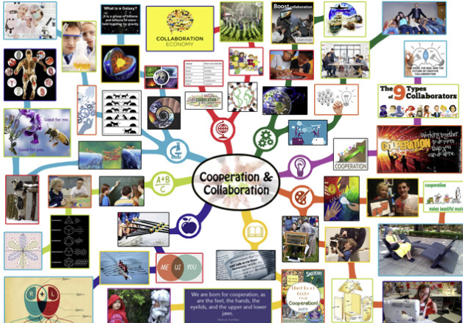

**WRITE: What are the benefits of working collaboratively and how can we work together more effectively? Discuss together and write 3 suggestions.**

**1)**

**2)**

**3)**

|  |  |
| --- | --- |
| **Vocabulary** | **Definition** |
| 1. …… contribution  2. …… productivity  3. …… expertise  4. …… to set an example  5. …… to stay focused  6. …… leadership  7. …… relationship-oriented  8. …. to bond with someone | a. the position or fact of being a leader, the qualities of a good leader  b. to develop a close connection to or strong relationship with someone  c. interested in personal relationships  d. to keep giving attention to one particular thing  e. something that you give or do to achieve something with other people  f. a high level of knowledge or skill in a particular subject  g. the rate at which a person or company produces things or does useful work  h. to behave in a way that other people should copy |

**READING COMPREHENSION - Effective collaboration**

Collaboration means two or more people working together to achieve a goal. Studies have found that working together makes people more motivated and helps them perform much better. People who are collaborating on tasks stay interested for longer, feel less tired and get better results than people who are working alone. Working together as a team allows people to achieve things that could never be done by just one person. What’s more, the communication needed in order for team members to share goals and explain ideas is part of a process that improves the quality of everyone’s thinking and contributions. Here are five tips for effective collaboration and strong teamwork that will improve productivity and get better results:

**1. Creating a culture of co-operation**

To achieve their goals effectively, team members need to co-operate and be generous with their resources, including their own talents. When people get to know the strengths of their individual team members, they can use the different skills and expertise in the team to their advantage. Team leaders can create a culture of co-operation by setting an example that includes spending time talking to and supporting individuals, and sharing their knowledge and resources with their team. If we see our team leaders being open and welcoming different ideas, we are more likely to do the same.

**2. Having clear goals and clear roles**

Working in a team without clear goals is like running in a race without a finish line. In order for team collaboration to be successful, members need to have clear goals and know their individual responsibilities. This not only helps them to stay focused and motivated, but it also helps them to understand how they can play their part in the team’s success.

**3. Leaders – focusing on tasks and relationships**

Objectives are important, but we mustn’t forget that a team is made up of people and their relationships to each other. The stronger those relationships are, the more likely the team is to be effective. A report by Harvard Business Review found that the most productive and innovative teams often have leaders with a flexible leadership style. They might start a project being task-focused and deciding the goals and roles in a team. But during the project, they might switch to a more relationship-oriented style, focusing on team-building and creating an environment of friendliness and trust.

**4. Having open communication lines** If we want our team members to work well together, communication is the key. We need to provide effective channels of communication and encourage people to share what they’re doing. Simply meeting once a week for updates is not enough. There are many project management tools like Microsoft Teams or Slack that provide a regular and open channel of communication with everyone. Another option could be creating a group on messaging apps like WhatsApp or LINE to offer team members a chance to informally communicate with others.

**5. Encouraging a spirit of community**

Companies often organise social events because they know the importance of creating a sense of community. The activity could be anything from a weekly lunchtime food share to a quiz afternoon. Or you can start with simple, everyday things like having coffee breaks together or creating a space to share books. Ideas like these all encourage collaboration by bringing people together and helping them bond with their colleagues. Collaboration is an opportunity to learn from each other and encourage fresh thinking, as well as a source of energy, strength and continued effort. As the saying goes, ‘If you want to go fast, go alone. If you want to go far, go together.’

**EXERCISE 1**

**Which ways of improving collaboration are mentioned in the article? Choose the five correct answers.** Spending time talking to team members and giving them help.

Organising a fun group activity for staff.

Encouraging each team member to compete against the others.

Making sure each team member understands their role in the project.

Limiting communication to weekly team meetings.

Focusing on the goals but also on the relationships that team members have with each other.

Ensuring that everyone on the team has the same point of view.

Encouraging informal communication and socialising between colleagues.

**EXERCISE 2**

**Write the correct form of the word in brackets.**

1. When two or more people work together to achieve the same goal, it is called …………… .(collaborate)

2. To achieve their goals ……………, team members need to share their resources. (effective)

3. Strong teamwork and effective collaboration will improve ……………… and get better results. (produce)

4. When people get to know the strengths of the people in their team, they can use their different skills and ……………… to their advantage. (expert)

5. The most productive and innovative teams often have leaders with a flexible ………… style. (leader)

6. There are many project ……………… tools that can provide a regular and open channel of communication with everyone. (manage)

7. Creating a group on messaging apps like WhatsApp or LINE offers team members a chance to communicate ……………… with others. (formal)

8. Collaboration is a source of energy, …………… and continued effort. (strong)

**DISCUSS**

**What other things do you think can help with collaboration in a team? Discuss together and think of 3 answers.**

**UNLOCK UNIT 8 ‘Collaboration’ – page 169**

**HOMEWORK FOR NEXT THURSDAY:**

**Re-read the last sentence of the article above: ‘If you want to go fast, go alone. If you want to go far, go together.’ Do you agree or disagree? Write an answer of circa 150 words.**

**Email homework to Rebecca.odoherty@unimc.it**