|  |
| --- |
| **L12 - LINGUA E TRADUZIONE INGLESE III**  **Modulo B Lingua e Traduzione per L’impresa Internazionale a.a. 2022-2023**  **LETTORATO Dott.ssa M. Condon/ Dott.ssa R.O’Doherty**  [**marie.condon@unimc.it**](mailto:marie.condon@unimc.it)  **rebecca.odoherty@unimc .it**  **9/2/2023** |

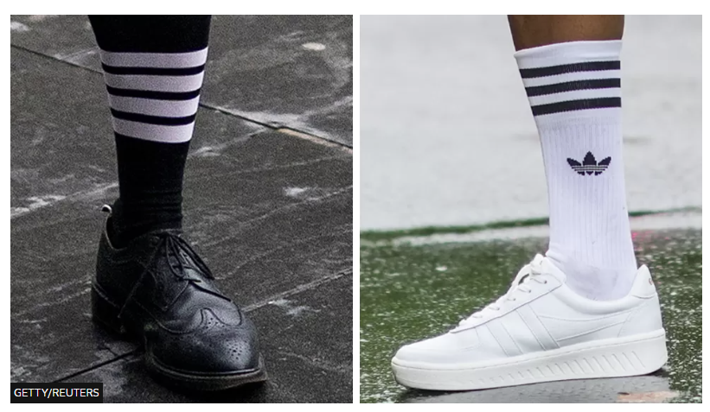

**HEADLINE: Adidas loses three-stripe trademark battle**

**TRUE / FALSE: Read the headline. *Guess* if 1-8 below are true (T) or false (F).**

1. A fashion company complained about the three stripes of Adidas.**T / F**
2. Adidas wanted $78 million in damages.**T / F**
3. A court in Manhattan decided against Adidas in infringement case.**T / F**
4. The court said consumers could easily confuse the two logos.**T / F**
5. The Thom Browne fashion house started over two decades ago.**T / F**
6. Thom Browne fashion designed a scarf for Joe Biden's fashion collection. **T / F**
7. Thom Browne used three stripes on a jacket in 2007.**T / F**
8. Thom Browne said the prices the two companies charged were similar.**T / F**

**2. SYNONYM MATCH: (The words in bold are from the news article.)**

1. trademark

2. complaint

3. claimed

4. infringe

5. confuse

6. founded

7. collaborated

8. switched

9. maintained

10. strikingly

a. confound

b. contravene

c. changed

d. protest

e. established

f. noticeably

g. applied for

h. asserted

i. logo

j. teamed up

**PUT THE TEXT BACK TOGETHER**

**Adidas loses three-stripe trademark battle**

( ) Thom Browne is a New York-based fashion house founded in 2001. It caters to the high-end fashion

( ) or reputation. Jurors decided that consumers were unlikely to confuse the two brands, as

( ) protested, Browne switched to a four-stripe pattern. Thom Browne maintained that

( ) name for itself in 2020 by designing a scarf as part of Joe Biden's "Believe in Better" fashion collection. The dispute

( ) stripe logo on its clothes. Adidas claimed the four stripes were too similar to its three stripes and filed

( ) confusion between the two designs was unlikely because the two companies "operate in different

( ) they were capable of distinguishing between three and four parallel stripes.

( ) with Adidas dates back 16 years. Browne used a three-stripe design on a jacket in 2007. After Adidas

( 1 ) Sportswear giant Adidas has lost a courtroom battle over a perceived infringement of its trademark three-stripe

( ) logo. Adidas lodged a complaint against the American luxury fashion brand Thom Browne, which uses a four-

( ) market and has collaborated with many top names in the world of luxury apparel. The brand made a

( ) court decided in Thom Browne's favour. It declared that the four stripes did not infringe on Adidas' logo

( ) a lawsuit. It attempted to claim more than $7.8 million in damages. However, a jury in a Manhattan

( ) markets, serve different customers, and offer their products at strikingly different prices".

**DISCUSS:**

1. What do you know about Adidas? What do you know about Thom Browne?
2. What do you think of logos and trademarks?
3. What do you think of luxury fashion?
4. How important are logos?
5. What is a product brand?
6. Why do companies brand products?

**QUICK RESEARCH: Find the origin of the following brand names:**

1. Toyota

2. Chanel no.5.

3. Rolls Royce

4. Reebok

5. Nike

6. Nivea

**LISTENING:**

You are going to listen to a conversation about branding between Tim, a business studies student who is working as an intern in the marketing department a large chocolate manufacturing company, and Carla, the marketing manager.

As you listen, make notes on Carla’s explanation of why branding is important for companies. Then listen and compare your answers with the explanations given in the discussion.

|  |
| --- |
| Notes: |

**Comprehension check: Marketing vocabulary**

***Here are some of the branding concepts Carla describes in the conversation. Match each marketing term she uses with its description below.***

1. differentiation

2. building awareness

3. recall

4. recognition

5. protecting the brand

6. communicating brand values

a. when customers remember a product they have already tried and liked when they see it again

b. stopping other companies and criminals from copying a product or making a bad version of a product

c. informing customers about a product that they don’t know about yet

d. using the company or brand name to reassure customers that the product is safe, reliable and good quality

e. making products distinctive, so that people make a deliberate decision to select them, rather than choosing them randomly

f. when customers are able to find a product because it stands out visually in some way (e.g. on supermarket shelves where lots of similar products are displayed)

**Discussion:** Think about some of the brands you know. How successful do you think they are in standing out from their competitors?

**TASK:**

Think of a new product or service you would like to launch. Then design a brand identity for it. You need to decide on the brand features mentioned in the conversation, i.e. the product name, the slogan, the design of the lettering and the colour of the packaging

If you can’t think of any ideas for a new product, use one of these ideas:

A thick slimy green jelly soda drink

An alarm clock that switches off when you shout at it

A new digital homework personal organiser

**HOMEWORK:**

**Send me an mp3 of yourself speaking for one minute about your favourite brand. Include the origin of the brand name, describe the logo, explain what it sells, and why you like it.**