|  |
| --- |
| **L12 - LINGUA E TRADUZIONE INGLESE III**  **Modulo A Lingua e Traduzione per L’impresa Internazionale a.a. 2022-2023**  **LETTORATO Dott.ssa M. Condon/ Dott.ssa R.O’Doherty**  [**marie.condon@unimc.it**](mailto:marie.condon@unimc.it)  **rebecca.odoherty@unimc .it**  **LESSON PLAN 30/11/2022** |

**LESSON LAYOUT**

1. **Language focus: the language of graphs and charts**
2. **Unlock Unit 6 pg 128 – 132**
3. **Homework: Describe your own graph (below)**
4. **GLOSSARY for speaking about graphs and charts**

**PUT THE WORDS IN THE APPROPRIATE COLUMN**



**LOOK AT THE WORDS ABOVE AND PUT THEM IN THE APPROPRIATE COLUMN**

|  |  |  |  |  |
| --- | --- | --- | --- | --- |
| **VERBS** | **NOUNS** | **ADJECTIVES** | **ADVERBS** | **CAN BE 2** |
|  |  |  |  |  |
|  |  |  |  |  |
|  |  |  |  |  |
|  |  |  |  |  |
|  |  |  |  |  |
|  |  |  |  |  |
|  |  |  |  |  |
|  |  |  |  |  |
|  |  |  |  |  |
|  |  |  |  |  |

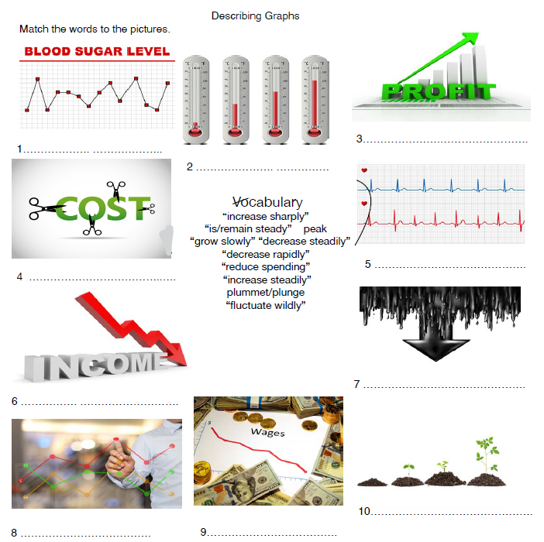

Now complete the sentences with your own ideas. Make sure you explain your point. You may like to write about aspects of your life such as: heartbeat, blood sugar level, free time, work, energy level etc.

Example: My income **fluctuates wildly** when I work part-time.

**1.**

**2.**

**3.**

**4.**

**5.**

**6.**

**7.**

**8.**

**9.**

**10.**

**Prepositions for describing graphs and charts**

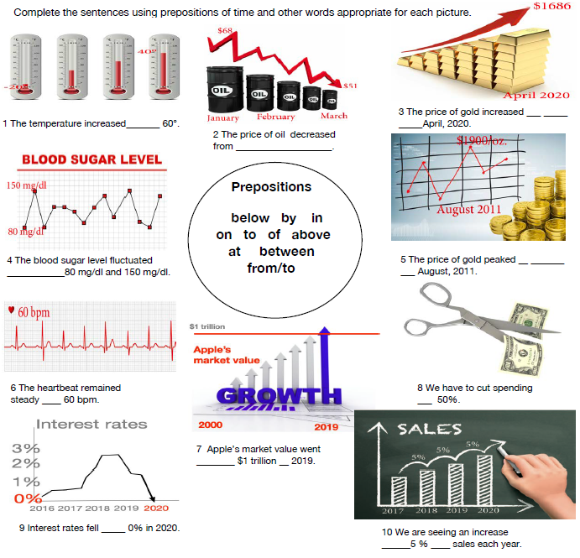

**Complete the following sentences with prepositions and your own ideas**

1 Last year my savings increased/ decreased _____ _____%.

2 I would worry if my heart increased ____ ______bpm.

3 I want to reduce my spending __ electricity from ______ to _________ each month.

4 I would like a salary increase ____ ___ % each year.

5 I would worry if my weight increased ____ __________.

6 My energy level often peaks ___ about _____ each day. (time)

**HOMEWORK (For Wednesday 7/12/22)**

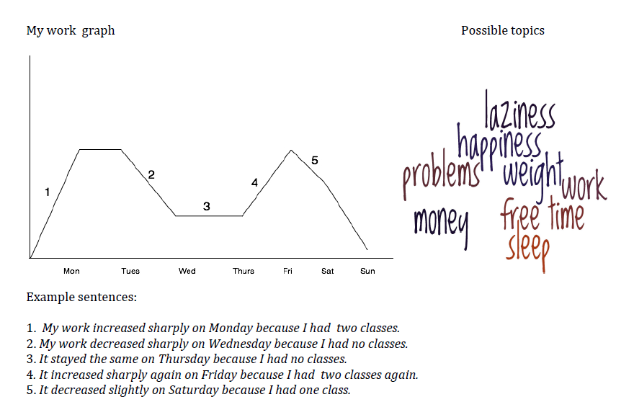

Look at the example “My work graph” above. Choose a topic (or think of your own topic) about your life from the “Possible topics” and draw your own graph. Then write five sentences

about your graph.