|  |
| --- |
| **L12 - LINGUA E TRADUZIONE INGLESE III**  **Modulo B Lingua e Traduzione per L’impresa Internazionale a.a. 2022-2023**  **LETTORATO Dott.ssa M. Condon/ Dott.ssa R.O’Doherty**  [**marie.condon@unimc.it**](mailto:marie.condon@unimc.it)  **rebecca.odoherty@unimc .it**  **22/2/2023** |

**MODALS OF DEDUCTION AND SPECULATION**

**Write a follow-on sentence to the sentences below, using modals of deduction and speculation.**

**Example** You almost fell off the cliff! That *must have* been terrifying.

1. He doesn't have a driving license.
2. How did they lose the game?
3. Why were there no taxis available?
4. The referee was standing right there when the tackle happened.
5. Let's go to the lost and found to see if they have your wallet.
6. I don't know for sure that my phone was stolen.
7. All my students' essays were on the wrong topic.
8. Can you please check to see if I've locked the door?
9. Oh, good! We've got bread.
10. He couldn't have made that table by himself.
11. Wow! Did you eat all that pizza yourself?
12. I can't find my wallet.
13. Where are my books?
14. Mum's car is parked outside.
15. Amy is on holiday in Bali this week.
16. I can't find John, and his jacket is here.
17. Anika isn't answering her phone.
18. What book did you bring to class today?
19. Look at his Rolex watch.

**Do worksheet resource ‘ModalsOfDeductionSpeculation’**.

**READING**:

Read the article. What sort of animals do the Nazca lines show?

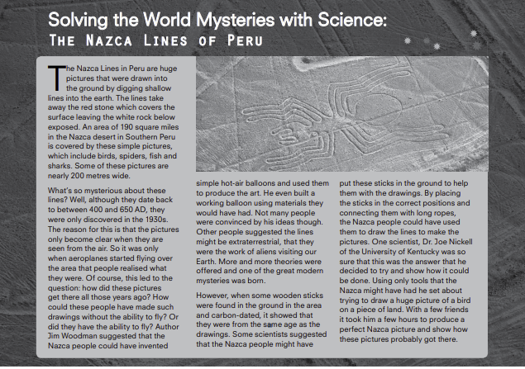

Read the article again and answer the questions.

1 How were the lines drawn?

2 When and how were the pictures discovered?

3 What is Jim Woodman’s theory?

4 What did he do to try and prove it?

5 How does Joe Nickell believe the lines were made?

6 What did he do to prove these ideas?

**What other theory can you come up with? Write your answer using modals.**

**DEVELOPING WRITING:** A blog entry about a mystery

**1 Read the blog entry and answer these questions:**

What does the writer think about the Bélmez faces? Were they fake or real?

What do you think? Were they fake or real?

**2 Blogs are often quite informal and chatty in their style. Where do these informal phrases fit into the text?** **[A] – [F]**

1 I’m not a big believer in paranormal activity and

2 Why?

3 One of the weirdest things I’ve ever heard about are the Bélmez faces.

4 Well that’s what I think.

5 probably not being too happy about it,

6 Millions of

**3 Match the phrases in Exercise 2 with the effect they have**.

**a** A way of introducing your own opinion

**b** A way of summing up your thoughts

**c** Using a question which you answer yourself to say what you think

**d** Using a superlative to introduce the topic in a dramatic way

**e** Exaggeration

**f** Imagining / supposing how someone must have felt

**HOMEWORK: (due 1st-2nd March)**

Do some research about a famous mystery from your country. Make notes and write an entry for a blog (informal language) in about 150-200 words. Explain the story behind it. Discuss some of the theories about it. Don’t forget to use modals of deduction.