|  |
| --- |
| **L12 - LINGUA E TRADUZIONE INGLESE III**  **Modulo B Lingua e Traduzione per L’impresa Internazionale a.a. 2022-2023**  **LETTORATO Dott.ssa M. Condon/ Dott.ssa R.O’Doherty**  [**marie.condon@unimc.it**](mailto:marie.condon@unimc.it)  **rebecca.odoherty@unimc .it**  **23/2/2023** |

**LESSON LAYOUT**

**Grammar Focus: Cleft sentences**

**Skill: Listening & pronunciation (Unit 8 textbook)**

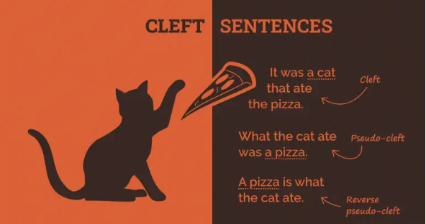

**Cleft sentences**

**Read these sentences and think about which information is being emphasised in each one.**

**1) Elton John wanted success.**

**2) What Elton John wanted was success.**

**3) Success was what Elton John wanted.**

**How could you re-write the last two sentences to shift the emphasis onto another piece of information?**

**EXERCISE 1:**

**1. ______ I would do is wait for instructions**.

a.That I said

b.What I said

c.It is what

d.What said

**2______ enjoyed most of the trip was the food**.

a.What I

b.All I

c.What

d.It's what I

**3______ everything started to fall apart.**

a.It was 2010 when

b.2010 it was

c.2010 was where

d.Was 2010 when

**4 David is ______ came up with the original idea. Choose TWO correct options**

a.the person who

b.that

c.the person that

d.the person

**5______ is to protect their family.**

a.The reason why they did it

b.How they did it

c.Because they did it

d.It's why they did it

**EXERCISE 2:**

**Read the re-worded paragraph for errors then correct the sentences below:**

**Original**

The J Street Band got together in an interesting manner. Lead singer Jeremy put the band together. He held a blind audition for interested musicians. The person he chose was surprising. He selected a guitarist who was 70-years old. His age made no difference—the guy rocked!

What makes a band successful is hard to say. That the fans like the band's songs and style matters most. Both talent and hard work are required. Most people don't realize how long musicians work *in the shadows* before achieving recognition.

**Reworded** (with errors)

How the J Street Band got together is an interesting story. It was lead singer Jeremy put the band together. What he did was held a blind audition for interested musicians. It surprising who he chose. The guitarist who he selected was 70-years old. It made no difference he was older—the guy rocked!

It hard to say what makes a band successful. What matters most is that the fans like the band's songs and style. What is required are both talent and hard work. What most people don't realize is how long musicians work *in the shadows* before achieving recognition.

**Are the following sentences grammatically correct?**

1.How the J Street Band got together is an interesting story.

2.It was lead singer Jeremy put the band together.

3.What he did was held a blind audition for interested musicians.

4.It surprising who he chose.

5.The guitarist who he picked was 70-years old.

6.It made no difference he was older—the guy rocked!

7.It hard to say what makes a band successful.

8.What matters most is that the fans like the band's songs and style.

9.What is required are both talent and hard work.

10.What most people don't realize is how long musicians work in the shadows before achieving recognition.

**EXERCISE 3: Fill each gap with a suitable word**

A: Didn't you arrive late yesterday?

B: No, ___ was John who arrived so late.

A: You don't understand me.

B: No, ___ I don't understand is why you do this to yourself.

A: Didn't you fly to Denver yesterday?

B: No, it ___ on Monday ____ I flew to Denver.

A: You hurt him!

B: ____ I did is tell him the truth. I think he deserved it.

A: Didn't we meet at this bar?

B: No, the _____ where we met for the first time was that karaoke bar in Brooklyn. Don't you remember?

A: I saw you at the station yesterday.

B: No, the person ____ you saw yesterday at the station was my twin bother.

A: You did it for the money.

B: No, the _____ why I did it was to save the company.

A: What happened then?

B: The only _____ I remember is something hitting the back of my head.

A: Did you call the police?

B: No, what I _____ was hide in the bedroom.

A: You did this to me!

B: No, I didn't. It was Sean _____ did this to you.

**Exercise 4: Complete the second sentence so that it emphasises the underlined words. Do NOT use contractions.**

1. I need one hour to fix the computer.

All _____________________

2. Tim spread the rumour.

_____ the rumour was Tim.

3. We are not questioning your hard work.

It isn't __________

4. I used to live in that house over there.

The place _________is that house over there.

5. We checked all the windows.

_______ check all the windows.

6. We sold everything except the couch.

The only _______ was the couch.

7. We arrived in Madrid in the evening.

It was ___________________

8. You need to sign here.

All ________________________

9. I would never ask Peter out.

The last __________ is Peter.

10. My cousin told us what had happened.

It was ___________________