|  |
| --- |
| **L12 - LINGUA E TRADUZIONE INGLESE III**  **Modulo A Lingua e Traduzione per L’impresa Internazionale a.a. 2022-2023**  **LETTORATO Dott.ssa M. Condon/ Dott.ssa R.O’Doherty**  [**marie.condon@unimc.it**](mailto:marie.condon@unimc.it)  **rebecca.odoherty@unimc .it**  **LESSON PLAN 23/11/2022** |

**LESSON LAYOUT**

1. **Reading and Discussion**
2. **Preparation of debate – overall language review**
3. **Unlock 5 – Unit 6**

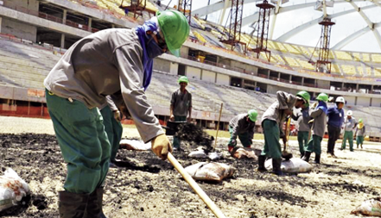

**1 Reading & Discussion**

**Read the headline from an article printed on 29th September 2013**

**4,000 COULD DIE BUILDING QATAR WORLD CUP**

An organisation called the International Trade Union Confederation (ITUC) looked at the working conditions of builders in Qatar. It is worried about the workers. It said they receive very low pay and their work is very dangerous. Sometimes employers do not give the workers their salary. The construction companies take away the worker's passports. The men do not get free drinking water, even though they work in temperatures of up to 50 degrees Celsius. Nepal's embassy in Qatar's capital city, Doha, said 44 Nepalese workers died in two months this summer. Most of the men died from heart attacks or workplace accidents. The ITUC says that up to 4,000 workers could die before the World Cup starts in 2022. Many people are shocked about the treatment of workers in Qatar. The ITUC said that what is happening at the World Cup building sites is like modern-day slavery. The Nepalese ambassador to Qatar, Maya Kumari Sharma, said the country was like "an open jail" for workers. Aidan McQuade, director of Anti-Slavery International, said the World Cup is being built using slave labour. Qatar's government also said it was shocked. A spokesperson said: "There is no excuse for any worker in Qatar to be treated in this manner. The health, safety, well-being and dignity of every worker that contributes to staging the 2022 FIFA World Cup is of the utmost importance."

**This article was written 9 years ago. With the benefit of hindsight, discuss how well it predicted the future and write 3 sentences on your thoughts.**

_____________________________________________________

_____________________________________________________

_____________________________________________________

**DEBATING**

**What is a debate?**

A debate is **a discussion or structured contest about an issue or a resolution**. A formal debate involves two sides: one supporting a resolution and one opposing it.

**How does a debate unfold?**

1. **Each side has 2 minutes to speak.**
2. **Then 1 minute to respond (rebuttal).**
3. **Then final remarks.**
4. **Then decision.**

**Example:**

**Team A: 2 minutes speaking**

**Team B: 2minutes speaking**

**Team A: 1minute reply**

**Team B: 1 minute reply**

**Team A: Final remarks**

**Team B: Final remarks**

**LANGUAGE FOCUS**

**Beginning a debate:**

**Rebuttal phrases:**

**Summarising language:**

**Topic of Debate:**

***The head of world football (FIFA) should have decided salaries and working conditions for workers building the stadiums, roads, hotels, etc. in Qatar.***

***Side A strongly supports this. (For)***

***Side B strongly opposes this. (Against)***

**Take 15 minutes to prepare your arguments. During the debate you will need to pay attention to what the other side says so that you can respond (rebuttal) properly.**

**\*Use the language we have focused on in the last month (emphasize and contrast, figurative and persuasive language [unit 4], summarizing and academic language [unit5])\***

**UNLOCK 6 -CAREERS**

**Work in pairs and brainstorm career and job training vocabulary for the following categories: Try to think of at least 4 words per category.**

|  |  |
| --- | --- |
| • looking for a job | • changing jobs |
| • job training | • career development |
| • qualifications |  |