|  |
| --- |
| **L12 - LINGUA E TRADUZIONE INGLESE III**  **Modulo A Lingua e Traduzione per L’impresa Internazionale a.a. 2022-2023**  **LETTORATO Dott.ssa M. Condon/ Dott.ssa R.O’Doherty**  [marie.condon@unimc.it](mailto:marie.condon@unimc.it)  rebecca.odoherty@unimc .it  **LESSON 6/12/2022** |

**LESSON LAYOUT**

1. **GRAMMAR FOCUS: NARRATIVE TENSES**
2. **UNLOCK UNIT 7 - LANGUAGE DEVELOPMENT:** 
   * + 1. **COHESION AND CONTRASTING**

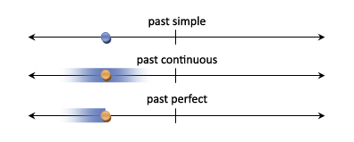

**1 Match Past Continuous sentences with the correct uses.**

**SAMPLE SENTENCES:**

1. a) I **was washing** the dishes when my mom called.
2. b) We **were living** in Berlin at the time.
3. c) What **were you doing** at 8pm yesterday?
4. d) While I **was playing** computer games, my girlfriend **was reading** a book.

e) It was a nice day and the sun **was shining**. We **were sitting** in our garden.

**USES OF PAST CONTINUOUS:**

1) Describing a scene in a story

2) Describing two actions happening at the same time in the past

3) Describing a past action in progress interrupted by another event

4) Describing an action in progress at a specific time in the past

5) Describing temporary situations in the past

**2. Now, write five sentences representing the different uses of Past Continuous from the previous exercise. Each sentence should include two verbs in the box.**

EXAMPLE: *When I was driving to work, my boss called to tell me some good news.*

buy call decide drive fall find hear look for meet see sing sit rain read ride walk watch wash

**1)**

**2)**

**3)**

**4)**

**5)**

**Narrative tenses: Past Simple, Past Continuous, Past Perfect**

**3. Look at the sentences below and decide which action happened first.**

1. 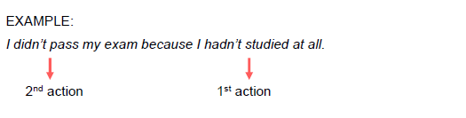
2. a) When I came back home, I realized that my car had been stolen.
3. b) We hadn’t booked the table, so we had to stand in a long queue waiting for a table.
4. c) When I got to work, the meeting had already finished.
5. d) I missed my train because I had overslept.
6. e) I left home, got into the car, and drove to work.
7. f) We hadn’t done the shopping, so we ordered a pizza.

**4. Studying the sentences from the previous exercise, choose the correct options in the rules below.**

1. a) We use Past Perfect to show which action happened ***first/second***
2. b) We use ***Past Simple/Past Perfect*** when actions happen immediately after each other
3. c) We use ***Past Simple/Past Perfect*** to give a reason for some event

**Narrative tenses: Past Simple, Past Continuous, Past Perfect**

**5. Complete the story below using Past Simple, Past Continuous and Past**

1. **Perfect, and the verbs in brackets.**
2. It was a nice day and the sun …………. (shine). I …………. (watch) the news when my dog got up and went to the door. Time for a walk. I …………. (put) on my jacket, …………. (take) my phone and …………. (leave) home. We went to the
3. park. While my dog …………. (run) around, I …………. (talk) on the phone with a friend. After some time, I got hungry so I went to a nearby food truck and ordered a hotdog. When it was ready, I wanted to pay but I realized that I …………. (not take) my wallet. I was quite embarrassed and the guy from the food truck wanted his money. I told him I didn’t have my wallet with me and I’d be back in 15 minutes with his money. He agreed but asked me to leave something as a guarantee. I decided to leave him my watch. I got home, took some money, and went back to pay for my hotdog. When I …………. (get) there, the food truck …………. (already leave) together with my watch.

**6. Work in pairs or groups. Come up with a story together. The first person builds a few sentences connected with the first two images. The next person continues the story by building more sentences based on the next two images.**

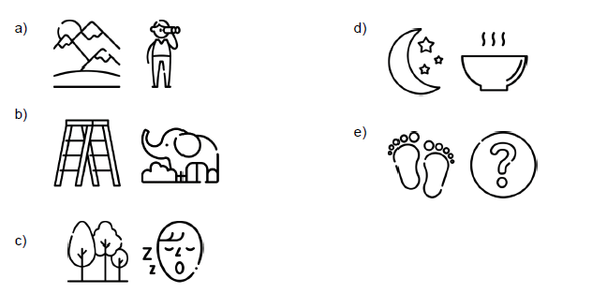

**USED TO + INFINITIVE, WOULD + INFINITIVE**

For each of the following sentences, choose either "used to" or "would". **If both are possible, use "would".**

1. 1. Do you remember how your Uncle David___________ sit in that chair and smoke those disgusting cigars.
2. 2. Your mother_________ have a Yorkshire Terrier when she was a young girl, didn't she?
3. 3. For years, they_________ go on holiday to the Rockies, but then it became very fashionable and, hence, expensive.
4. 4. Years ago, I_________ write a diary every day but then I got bored with doing it and I stopped. Maybe it was my life that was boring!
5. 5. At the start of their marriage, they__________ be very happy - but then it all went wrong!
6. 6. You__________ spell so well. Whatever happened?
7. 7. When I was five, I_________ be able to do incredible gymnastics. Now I can't even touch my toes.
8. 8. Before getting my driving licence, I___________ ride a bicycle everywhere.

UNLOCK – UNIT 7

Pronunciation for listening

Language development: Establishing cohesion and contrast

HOMEWORK FOR NEXT THURSDAY:

Write a concise summary of a novel you have read or a film you have watched recently. Use the narrative tenses we have reviewed in this lesson to summarize the plot. Write 100-150 words.