|  |
| --- |
| **L11 ii anno**  **a.a. 2022-2023**  **LETTORATO Dott.ssa R.O’Doherty**  **rebecca.odoherty@unimc .it**  **LESSON 28/2/2023** |

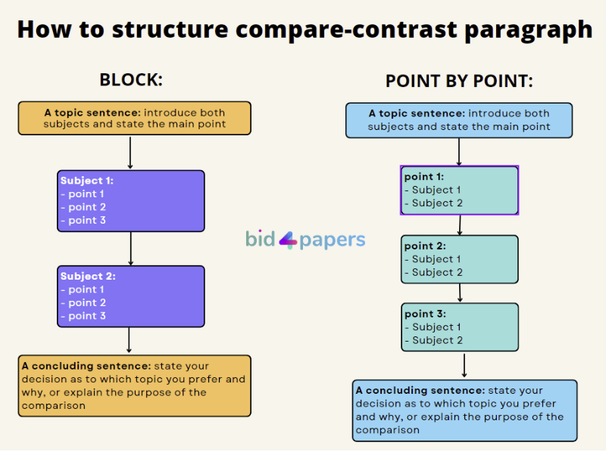

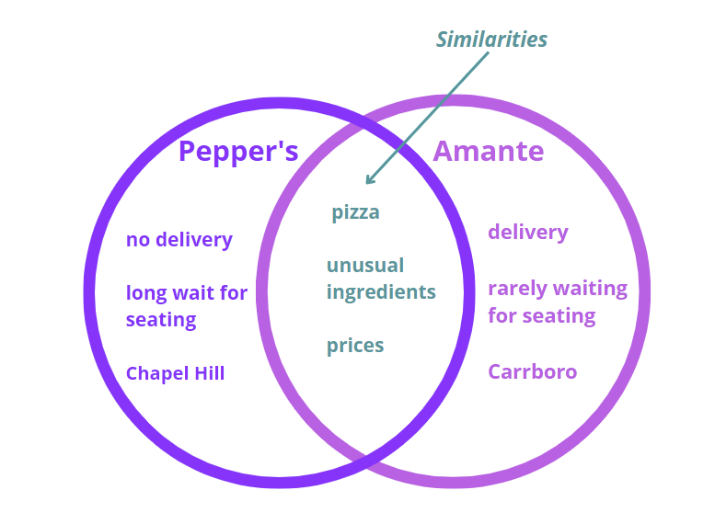

**Sample Block paragraph** 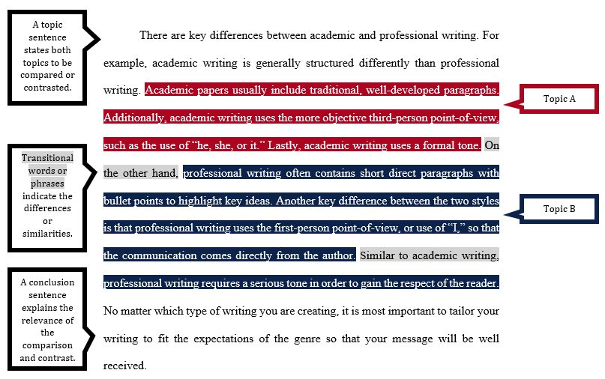

**Sample point-by-point paragraph**

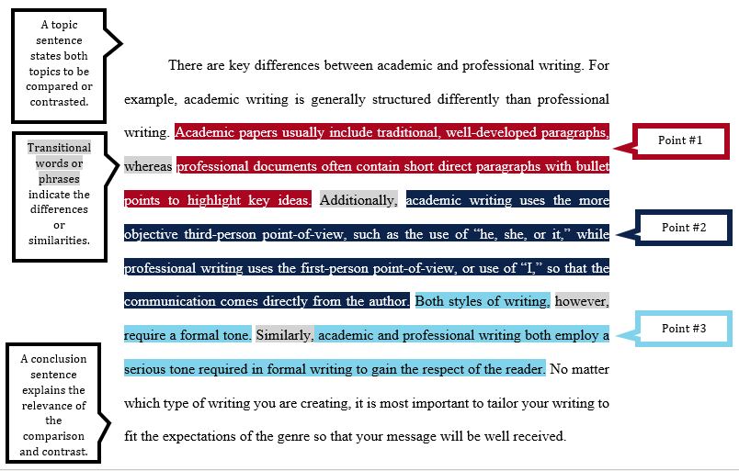

**COMPARE AND CONTRAST ESSAY WRITING**

**Choose the word or phrase from the box below to correctly complete the sentences 1-13.**

worlds apart in common distinguish chalk and cheese

similar contrast distinction by way of contrast

whereas difference identical differ discriminate

1) British people and people in my country have a lot __________________.

2) The __________________ in weather between my country and that in the United Kingdom is very noticeable.

3) The United Kingdom and my country __________________ a lot in many respects.

4) A lot of British people are not aware that there is a big __________________ between the Spanish and Portuguese languages.

5) I find it difficult to __________________ between British English and American English.

6) There's a big __________________ between learning a language and actually using it.

7) In my country, it is illegal to __________________ between men and women.

8) My country covers a large area. __________________ , the United Kingdom is quite small.

9) Customs in my country are __________________ to those in the United Kingdom.

10) As far as I can tell, young people in the United Kingdom are physically __________________ to young people in my country. They look exactly the same.

11) In my country, people eat to live , __________________ in the United Kingdom people live to eat.

12) Young people in my country share the same interests as those in the United Kingdom, but in other respects we are as different as __________________ .

13) Physically, my country is quite close to the United Kingdom, but culturally we are __________________.

Source: https://www.tolearnenglish.com

**Extra resources: How to write a compare and contrast essay (circa 3mins)** <https://www.youtube.com/watch?v=mdRDRZ_L8Rs>