|  |
| --- |
| **L11 ii anno**  **a.a. 2022-2023**  **LETTORATO Dott.ssa R.O’Doherty**  **rebecca.odoherty@unimc .it**  **LESSON PLAN 6/2/2023** |

**DISCUSS in pairs: If you could do anything to make your community better, what would you do? Think of three things and write them below.**

**1)**

**2)**

**3)**

**READING (UNIT 1, pgs 12-14)**

1. **In paragraph 3, what does the author mean when she says, “… it is precisely their 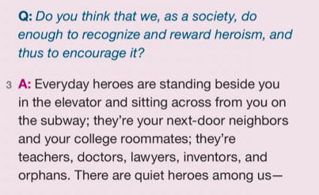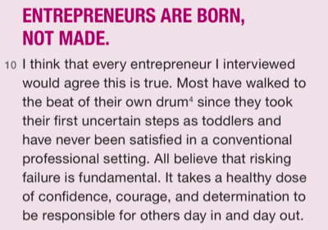ordinariness that makes them extraordinary”?**
2. **Using your own words, what is the main idea of paragraph 10?**
3. **Can someone who doesn’t fit the description in paragraph 10 still be a hero? Why or why not?**

**QUICK REVIEW: How to structure your essay: ANALYSIS ESSAY.**

**MODEL ESSAY: Read the model essa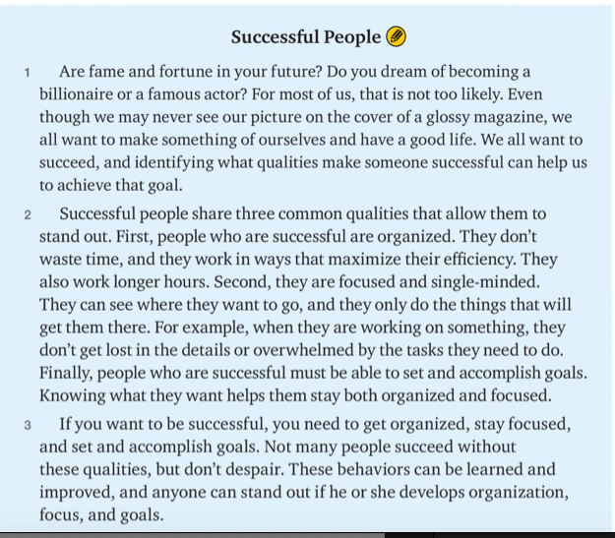y. Then follow the steps below.**

1. **Read the introduction again. Circle the hook.**
2. **Find the thesis statement in the introductory paragraph. Underline the topic once. Underline the controlling idea twice.**
3. **Underline the topic sentence of the body paragraph.**
4. **One sentence in the body doesn’t contribute to the unity of the essay, because it doesn’t develop the topic. Draw a line through it.**
5. **Circle the tr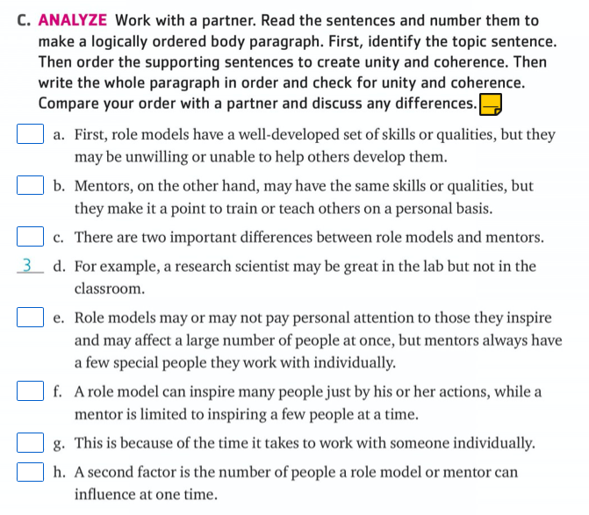ansition words that contribute to the coherence of the body paragraph.**
6. **Read the conclusion again. Circle the answer that best describes what the conclusion does.** 
   1. **It restates the thesis statement and suggests further examination of the topic.**
   2. **It summarises the main points and suggests ways tone successful.**
   3. **It restates the thesis statement and summaries the main points.**

|  |
| --- |
| Re-write the paragraph in the box below: |
|  |

**The paragraph above is the body paragraph for an essay about role models and mentors. Answer the questions.**

1. **List some possible hooks for an introduction to this paragraph.**

**________________________________________________________________**

**________________________________________________________________**

2**. Choose the best thesis statement for the essay.**

* + - **We all need both role models and mentors.**
    - **Role models and mentors are both admirable but their effect on our lives will be very different.**
    - **Both role models and mentors are admirable.**

3**. What is the best way to conclude this essay (notes only) ?**

**________________________________________________________________**

**PRACTICE: Write the information below into the correct category**

|  |  |  |
| --- | --- | --- |
| INTRODUCTION | BODY PARAGRAPH | CONCLUSION |
|  |  |  |

**Supporting information hook summary of main points thesis**

**look beyond essay to further ideas restatement of thesis background information**

**transition words for coherence topic sentence**

**HOMEWORK:**

**Write the introduction and conclusion to the paragraph you have been working on above.**

**Email homework to rebecca.odoherty@unimc.it**