L11 ii anno
a.a. 2022-2023
LETTORATO Dott.ssa R.O’Doherty
rebecca.odoherty@unimc .it

LESSON 15-16/2/2023

LANGUAGE FOCUS: Descriptive language
GRAMMAR FOCUS: Collocations (adjective+noun/adverb+adjective)

Discuss together:
Do marketers need to use different strategies to capture the attention of different age groups?
Why/why not? What do you think is the best way for marketers to get the attention of these age groups: 15-29, 30-44, 45-59, 60+?

VOCABULARY FOCUS 1 Choose 4 of the words from the vocabulary box (page45) and use them in a sentence: (5mins to write, >5 mins to read out)
1.
2.
3.
4.
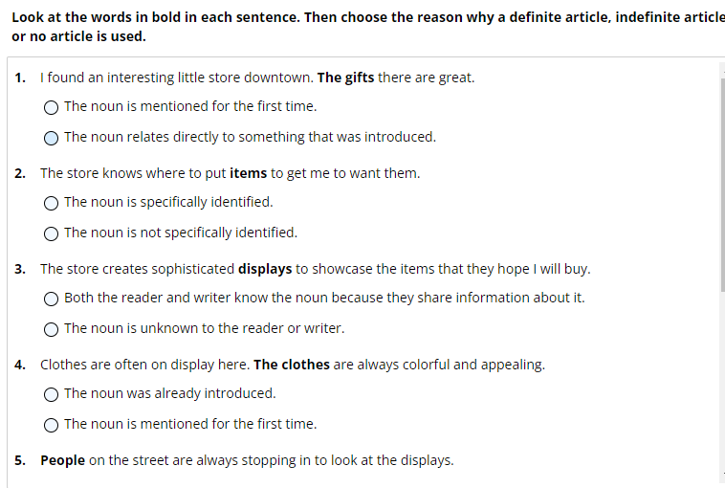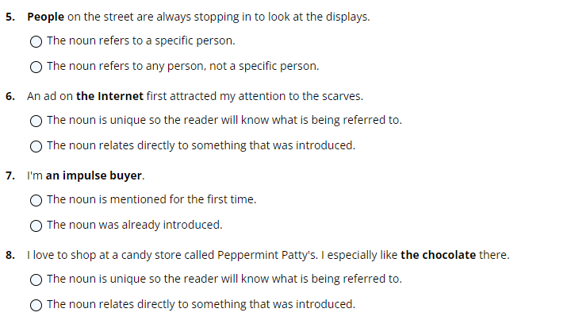

HOMEWORK FOR 22ND-23RD February: WRITE A DESCRIPTIVE ESSAY DESCRIBING AN AFVERTISMENT FOR A PRODUCT, BUSINESS OR SERVICE. BE SURE TO INCLUFE A THESIS STATEMENT THAT TELLS WHY IT IS YOUR FOCUS AND BODY PARAGRAPHS THAT DESCRIBE THE SPECIFIC FEATURES OR QUALITIES OF THE ADVERTISEMENT.
EMAIL HOMEWORK TO ME AT rebecca.odoherty@unimc.it

