|  |
| --- |
| **L11 ii anno**  **a.a. 2022-2023**  **LETTORATO Dott.ssa R.O’Doherty**  **rebecca.odoherty@unimc .it**  **LESSON 21/2/2023** |

**DISCUSS:**

1. What important lessons do we learn as young people?

2. As you were growing up, what did your parents teach you about responsibility? About manners? About the importance of family? About hard work?

**Making inferences – extra practice.**

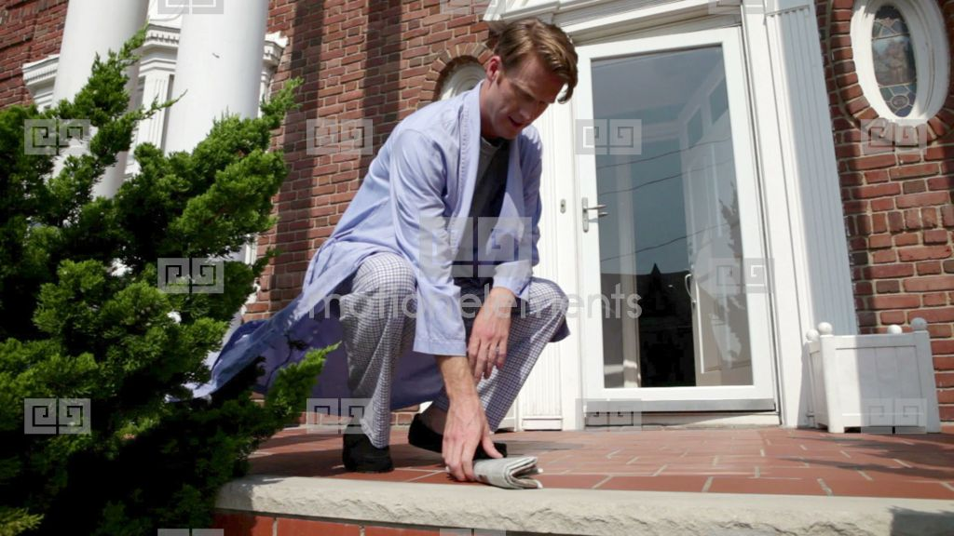

Mr. Thomas sat on the front porch of his house in a bathrobe and slippers. He put his head in his hands. He was holding the newspaper. His neighbors leaving their houses and getting in their cars. Mr. Thomas sighed. His neighbor Mr. Rosencrantz came out and saw Mr. Thomas. "Did it again, huh?" said Mr. Rosencrantz. Mr. Thomas said, "Yep." Mr. Rosencrantz laughed and said, "Here, Mr. Thomas, you can use my cell phone." Tom thankfully grabbed the cell phone and called his wife. "Honey, I did it again." Mr. Rosencrantz heard Mrs. Thomas yelling at Mr. Thomas through the phone. "Yes, dear. I'm so sorry. I'll see you soon," Mr. Thomas returned the phone to Mr. Rosencrantz, sighed deeply, and ran his fingers through his hair.

1. What is the thing that Mr. Thomas "did again"?__________________________________

How do you know?

1. Why will Mr. Thomas see Mrs. Thomas soon? _____________________________________

How do you know?

**Write the past tense form of the verb:**

Hear - _________

Sit - _______

Sigh - ________

Return - __________

Come - _________

Do - _______

Say - _______

Grab - __________

Call - ________

See - ________

Run - _________

4. Describe a time when you locked yourself out of your house or apartment.

PAST TENSES FOR NARRATIVE ESSAY - Please open pdf “L11 Narrative Tenses Feb 2023”